# How to run the program

The real-life data taken from the website discussed in the report can be found in a folder named “input_Data”. Copy as many folders from “input_Data” as the user desire and paste them in the “Ecoli” folder in both projects.

Use any Java IDE and import the project. Here is the steps using Eclipse (<https://www.eclipse.org/downloads/download.php?file=/oomph/epp/2018-09/R/eclipse-inst-win64.exe>)

Select File -> Import

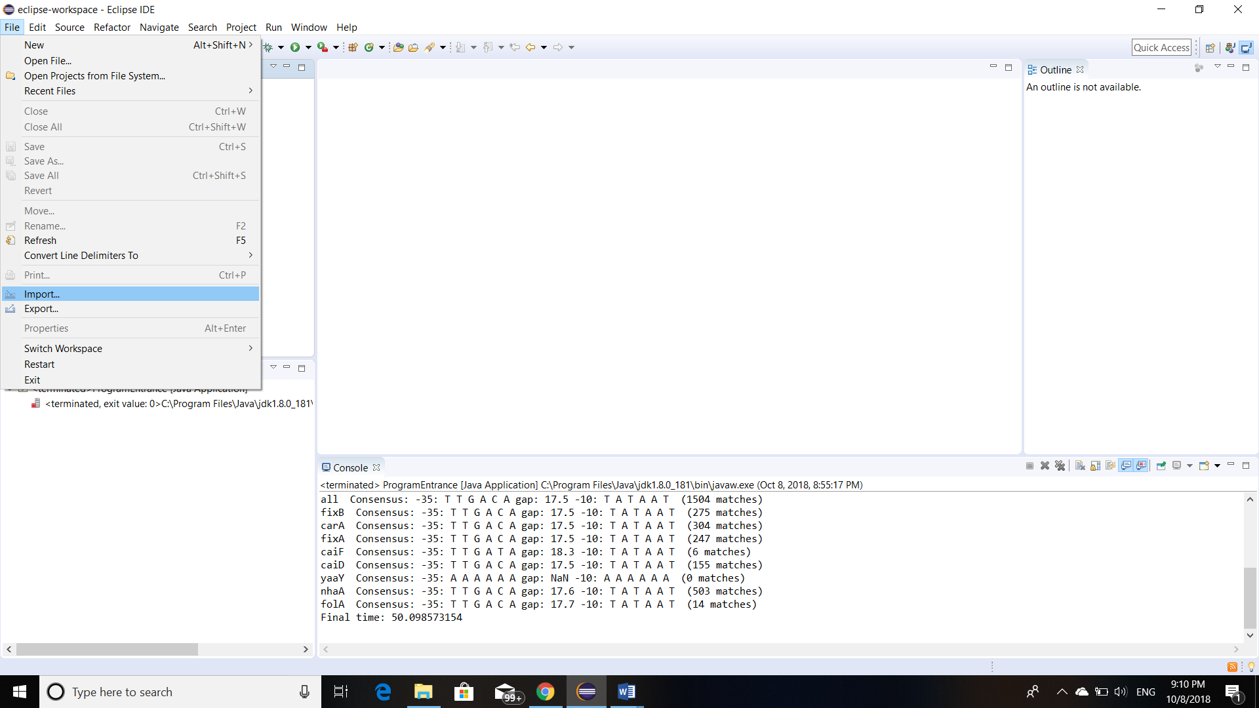

Choose “Project from Folder or Archive” then click “Next”

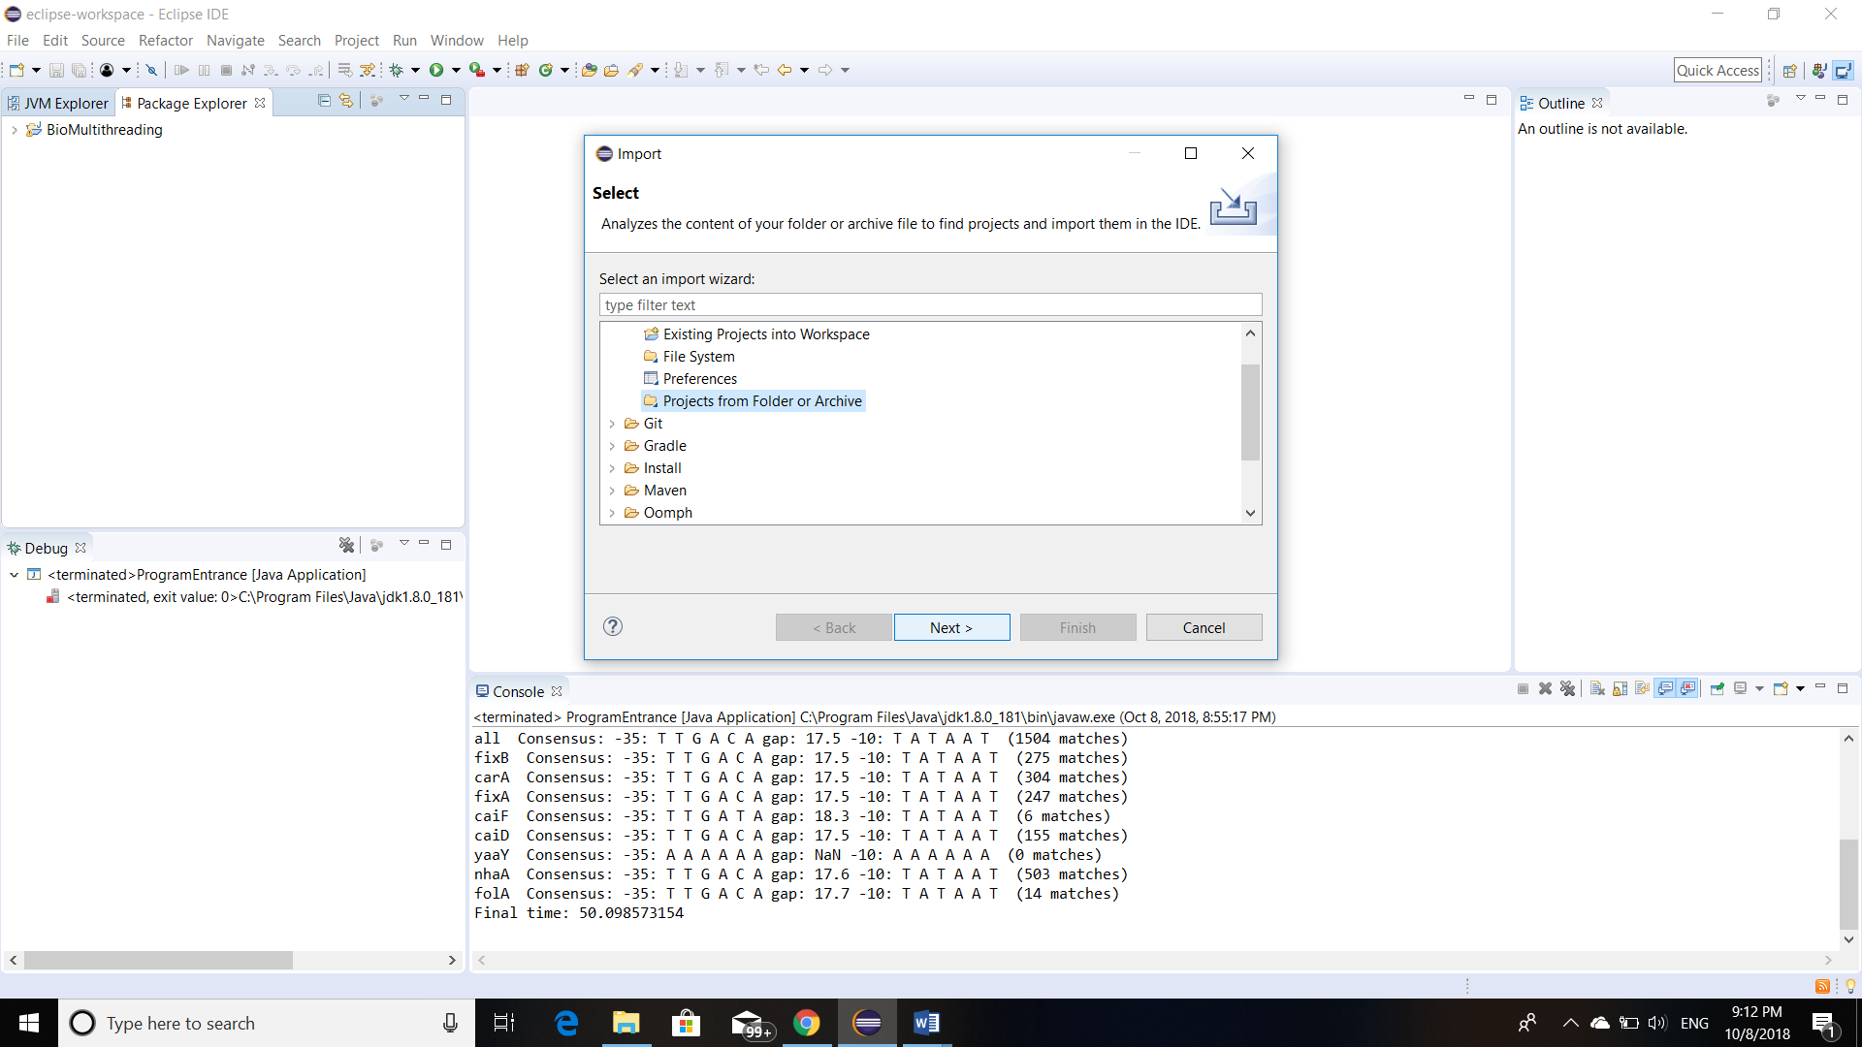

Next, click “Directory…”

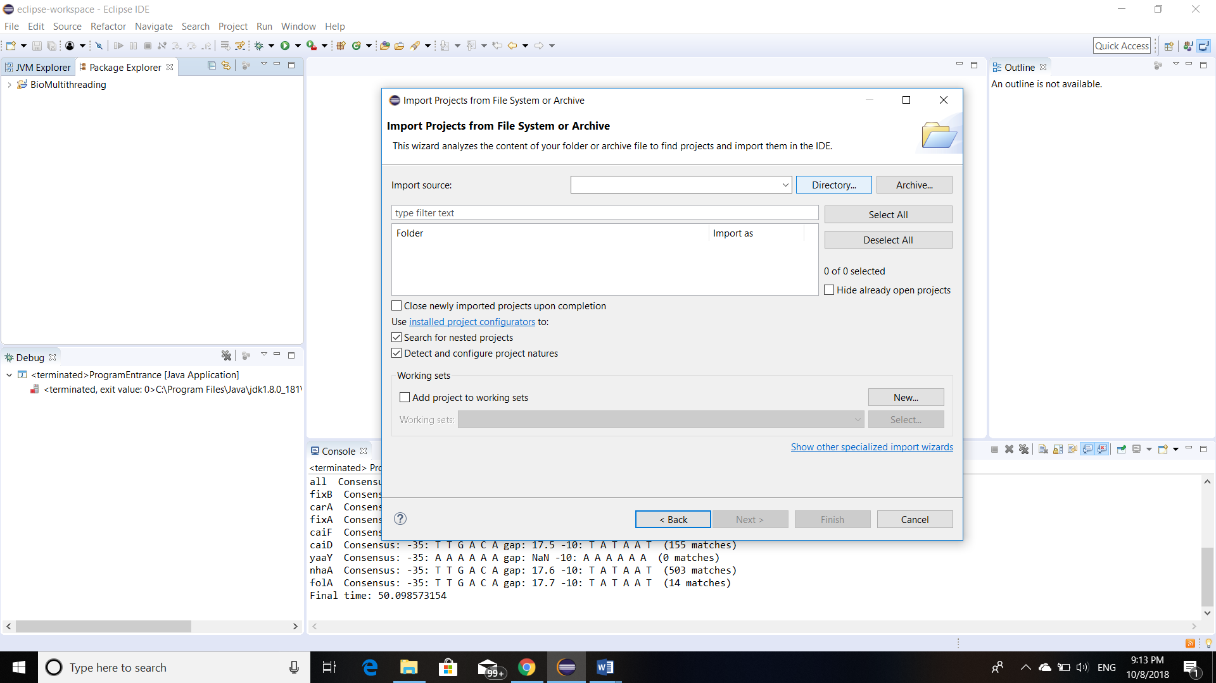

Then go to the project you want to import, and click “Select Folder”

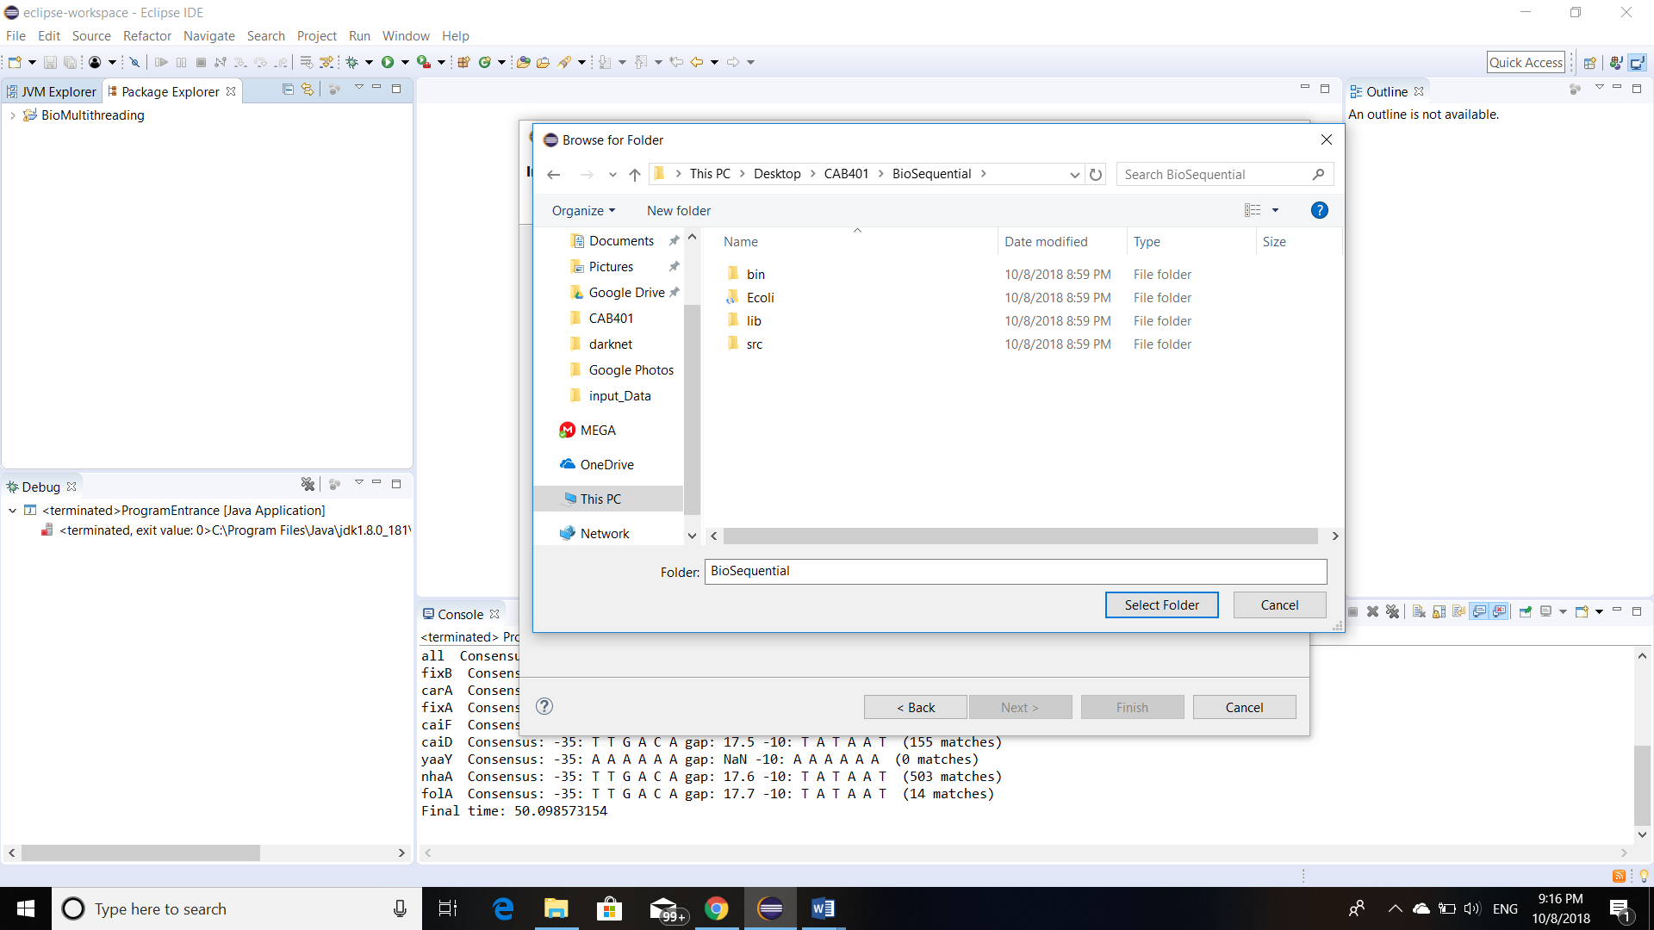

The project will be loaded, and you just need to click “Finish”

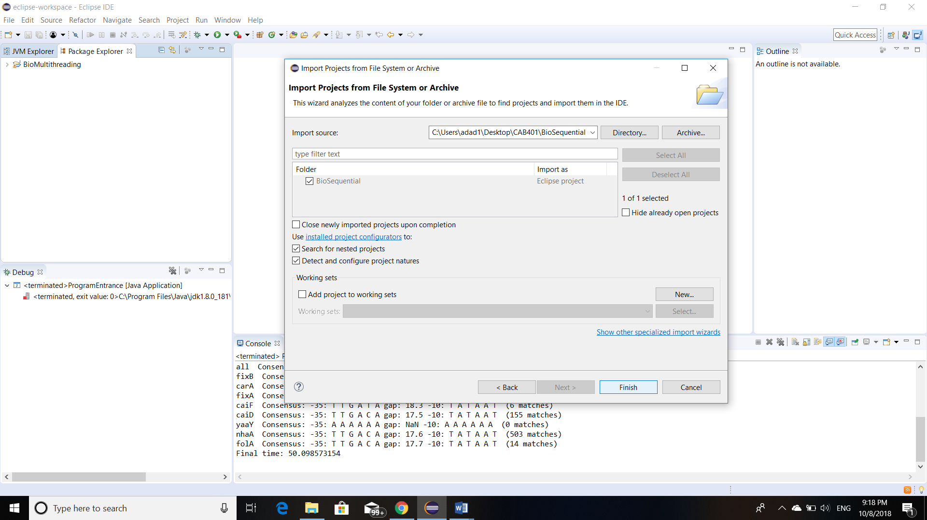

## Run BioSequential

“Sequential.java” is the main class to run the program from:

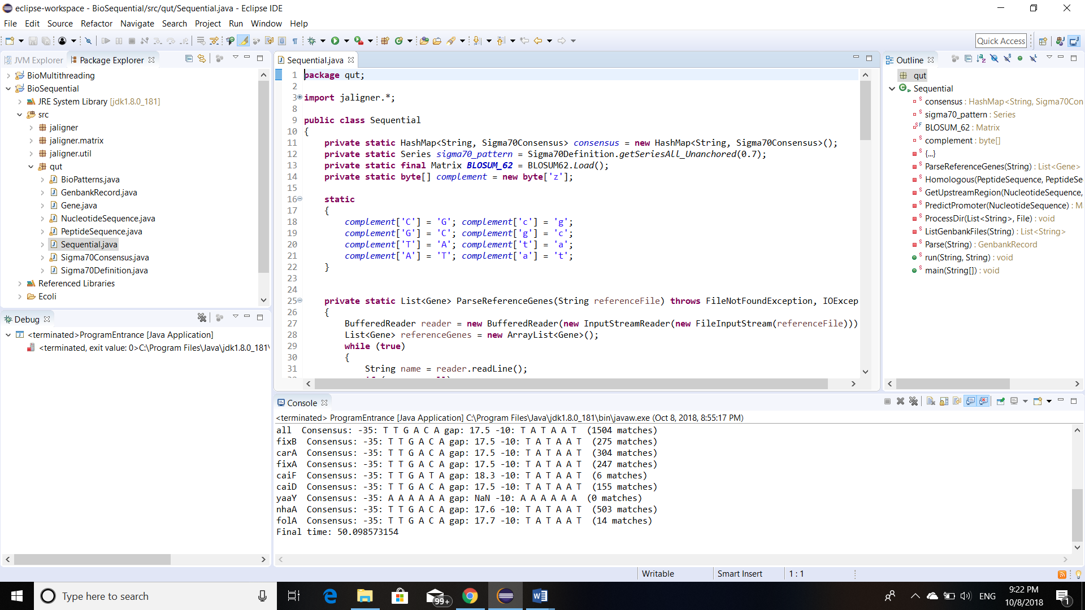

Open the file and click run.

## Run BioMultithreading

“ProgramEntrance.java” is the main to run the program from:

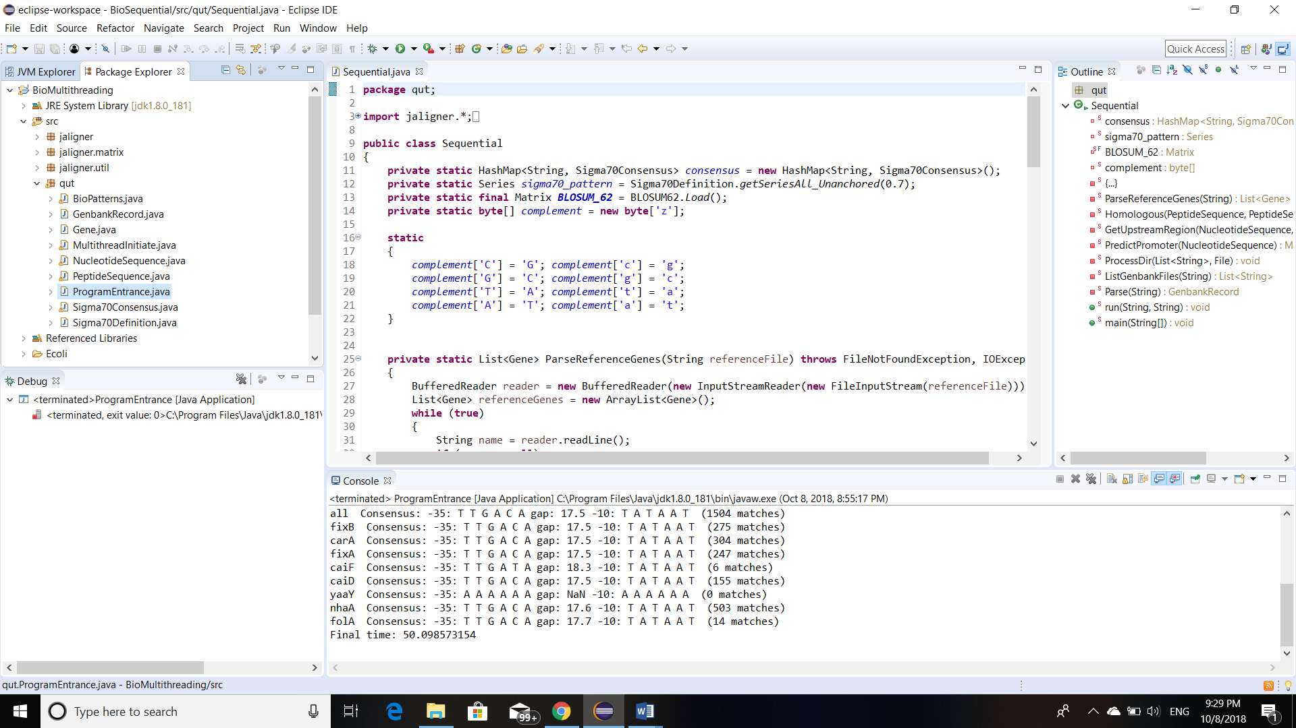

Open the file and click run.